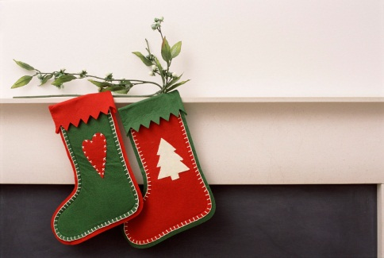

**Coaldale Public Library Friends Society**

**Handmade for Christmas Sale November 16, 2024**

**Exhibitor Information Package**

**For more information:**

**Coaldale Public Library at (403) 345-1340 or help@coaldalelibrary.ca**

The Coaldale Public Library Friends Society’s Craft Fair will bring together the arts and crafts community of Coaldale and area. As an exhibitor at the Craft Fair, your small/independently owned craft business will enjoy the benefit of aligning with the Coaldale Public Library and the Coaldale Public Library Friends Society to create a positive seasonal experience for our community and give you a venue to sell your handmade arts and crafts.

**This Fair will be held on Saturday, November 16th at the Coaldale Public Library (2014 – 18 Street) from 11 am – 4 pm**

**Exhibitor Fees ($25/table) + donation of an item for a door prize**

* $25/table for small arts and crafts vendors’ table size 6’ x 30” and 2 chairs. Electrical outlets are limited and will be available on a first come, first served basis based on date of registration.
* Each vendor will also be asked to donate an item for patron door prizes to be given out during the day of the sale.
* Exhibitor space will only be confirmed upon receipt of both the registration form and full payment. There will be no refunds for cancellations after November 6, 2024.

**Exhibitor Regulations**

1. Please provide a detailed description of your products and activities on the registration form. Only those vendors who wish to sell **homemade crafts or edibles** will be accepted for inclusion in the fair.
2. The Library reserves the right to reject exhibitor applications whose equipment, display or presentation is not in keeping with our fair’s objectives as an all-ages community event. If for any reason an exhibit, their staff or contents are deemed objectionable by library management, the exhibit will be removed without refund.
3. Exhibitors are responsible for set-up & take down. Displays may be set up between 9:30 am and 11:00 am on Saturday, November 16, 2024.
4. Exhibitors must contain all materials, demonstrations, and promotions within the boundaries of their exhibit space/table. **ADDITONAL DISPLAY RACKS/TABLES BLOCKING ACCESS TO LIBRARY MATERIALS WILL NOT BE PERMITTED.**
5. Exhibitors agree to remove their exhibits from the library by 5:00 pm November 16, 2024 (and not before 3 pm). If the exhibit is not dismantled by this time, library staff will take down the exhibit and exhibitors will be billed for any costs incurred. In this event the library accepts no responsibility for damage to the exhibitor property or equipment.
6. The Coaldale Public Library will provide signage directing patrons to exhibitor areas, but does not provide signage for each exhibitor booth.
7. Exhibitors are responsible for collecting, bagging and removing their own garbage and recycling materials. Bins will be available on site.
8. The Coaldale Public Library and Coaldale Public Library Friends Society makes no guarantees, direct or implied, as to the attendance or number of participants at the fair.

**Important:**

The Coaldale Public Library and the Coaldale Public Library Friends Society is responsible for hosting and organizing the Craft Fair. The Exhibitor agrees to indemnify and hold harmless the Coaldale Public Library or the Coaldale Public Library Friends Society, and any other participants from and against any direct or indirect loss or damage to persons or property caused by any act of the Exhibitor, its employees, servants or agents. The Coaldale Public Library or the Coaldale Public Library Friends Society shall not be held responsible for any direct or indirect loss or damage of any kind or nature, however caused, incurred by the Exhibitor, its employees, servants or agents, as a result of its occupation of exhibit space or other participation in the Craft Fair.

**Coaldale Public Library Friends Society Craft Fair - Exhibitor Registration Form**

**Application Deadline: November 4th, 2024**

***\*\*Full payment must accompany registration** Payment must be made by cash or cheque (payable to: Coaldale Public Library Friends Society)***

|  |  |
| --- | --- |
| **Business*/*Organization Name:** | |
| **Contact (first and last name):** | **Alternate Contact (first and last name):** |
| **Email:** | **Website/etsy account:** |
| **Mailing Address:** | **Phone/fax:** |
| **Please provide details of your planned activities (photo of products appreciated):** | |
| **Exhibit Rate of $25 includes one 6 foot long table and two chairs.**  **Do you require a plug in? _____ YES ______ NO** | |
| **I acknowledge that I have read and understand the exhibit information package.** There will be no refunds for cancellations after **November 6, 2024.**  **Print name: Signature:**  **Date:** | |

**Please submit form in person or by mail with payment to:**

Coaldale Public Library Friends Society

Att: Kindra Birss

Box 1207, 2014 18 Street

Coaldale AB T1M 1N1

OFFICE USE ONLY

Payment received cash/cheque (circle one) by (initials) __________ on (date) ________________