

**This month’s spice: Cinnamon**

Cinnamon instantly conjures up images of warm, fragrant kitchens, with the comforting aroma of baked goods – especially in the fall and winter. But this spice also contributes to the taste of exotic dishes and is found in a wide variety of cultural cuisines. From ancient Egypt where it was used in embalming rituals, to the medieval physicians who valued it for its health benefits, to the modern-day chefs and home cooks who consider it an essential ingredient in their arsenal, cinnamon's appeal is truly timeless. Its unique flavor - a delightful blend of sweetness and spice, with a hint of woody complexity - has the power to transform a dish. But cinnamon is not a one-note spice. It's a symphony of flavors, a spice that's as versatile as it is delicious. It's equally at home in a comforting mug of hot chocolate as it is in a fiery Indian curry. It's the spice that bridges the gap between comfort and adventure.

**Flavor profile:** Cinnamon is sweet but slightly bitter in flavor. It’s rich, sharp, spicy and earthy, making it a warming spice. It’s not truly sweet on its own, but brings out the sweetness in other foods.

**Cuisines that cinnamon is used in:** Mediterranean, Mexican, Middle Eastern, Indian, Chinese, South American, South Asian, Spanish, North American and European.

**Pairs well with:** allspice, apples, baked goods, bananas, blueberries, cardamom, chicken, chocolate, coffee, cloves, curries, custards, desserts, ginger, hot drinks, lamb, nutmeg, orange, pears, pecans, pork, rice, tea, vanilla, red wine.

**Cookbook recommendations available at Coaldale Library:**

* Taste of Home – All New Christmas Cookies
* Batch Baking
* Easy Mexican – 37 Classic Recipes
* The Essential Asian Cookbook
* Indian Cooking Unfolded
* The Complete Chinese Cookbook

**Cookbook recommendations available within Chinook Arch:**

* Greekish – Everyday Recipes with Greek Roots
* Mexican Recipes – Traditional Recipes for the Perfect Mexican Feast
* Authentic Indian Cooking With Your Instant Pot
* A Very Chinese Cookbook
* The Malaysian Kitchen
* A Taste of Latin America

**Beef Kafta**

Recipe from Reddit

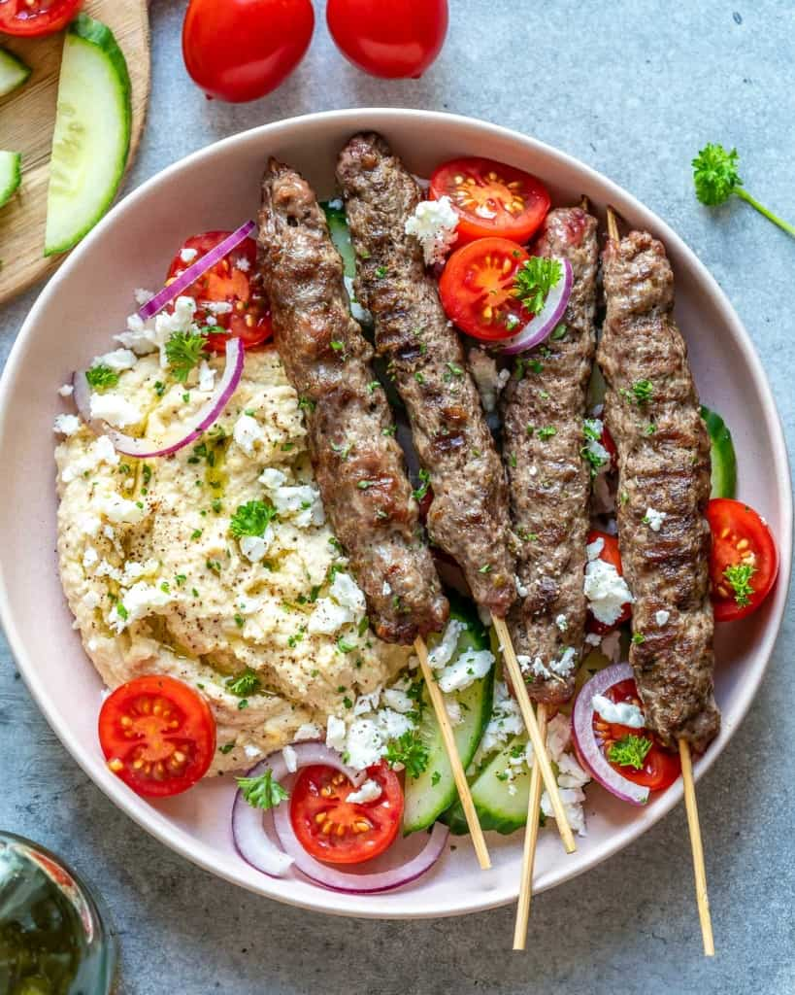

Serves 4

Ingredients:

Lebanese Seven Spices (Kafta) Seasoning:

* 1 tbsp ground allspice
* 1 tsp ground cumin
* 1 tsp ground cinnamon
* 1 tsp ground coriander
* 1 tsp ground turmeric
* 1 tsp ground ginger
* 1 tsp black pepper

Fresh parsley

Half an onion, finely chopped

1 lb ground beef or lamb

Instructions:

Combine all ingredients and mix until well combined. Form into a 6-inch oblong shape of about 1-inch in thickness, either on a skewer or without. Grease grill and preheat to medium-high heat. Grill 8-10 minutes, turning a couple times for even browning. Serve with accompaniments like labneh or Greek yogurt, rice, tomato/cucumber salad and pita.

**Horchata**

Recipe from Allrecipes



Serves 6

Ingredients:

* 5 cups water
* 1 cup uncooked white long-grain rice
* 2/3 cup white sugar
* ½ cup milk, or almond milk
* ½ tablespoon vanilla extract
* ½ tablespoon ground cinnamon

Instructions:

Pour water and rice into a blender; mix until rice begins to break up, about 1 minute. Let rice and water stand at room temperature for at least 3 hours.

Strain rice water into a pitcher and discard rice. Stir in sugar, milk, vanilla, and cinnamon.

Chill thoroughly before serving over ice.

**Vietnamese Cinnamon-Braised Beef Stew (Thit Bo Kho)**

Recipe by PCC Markets

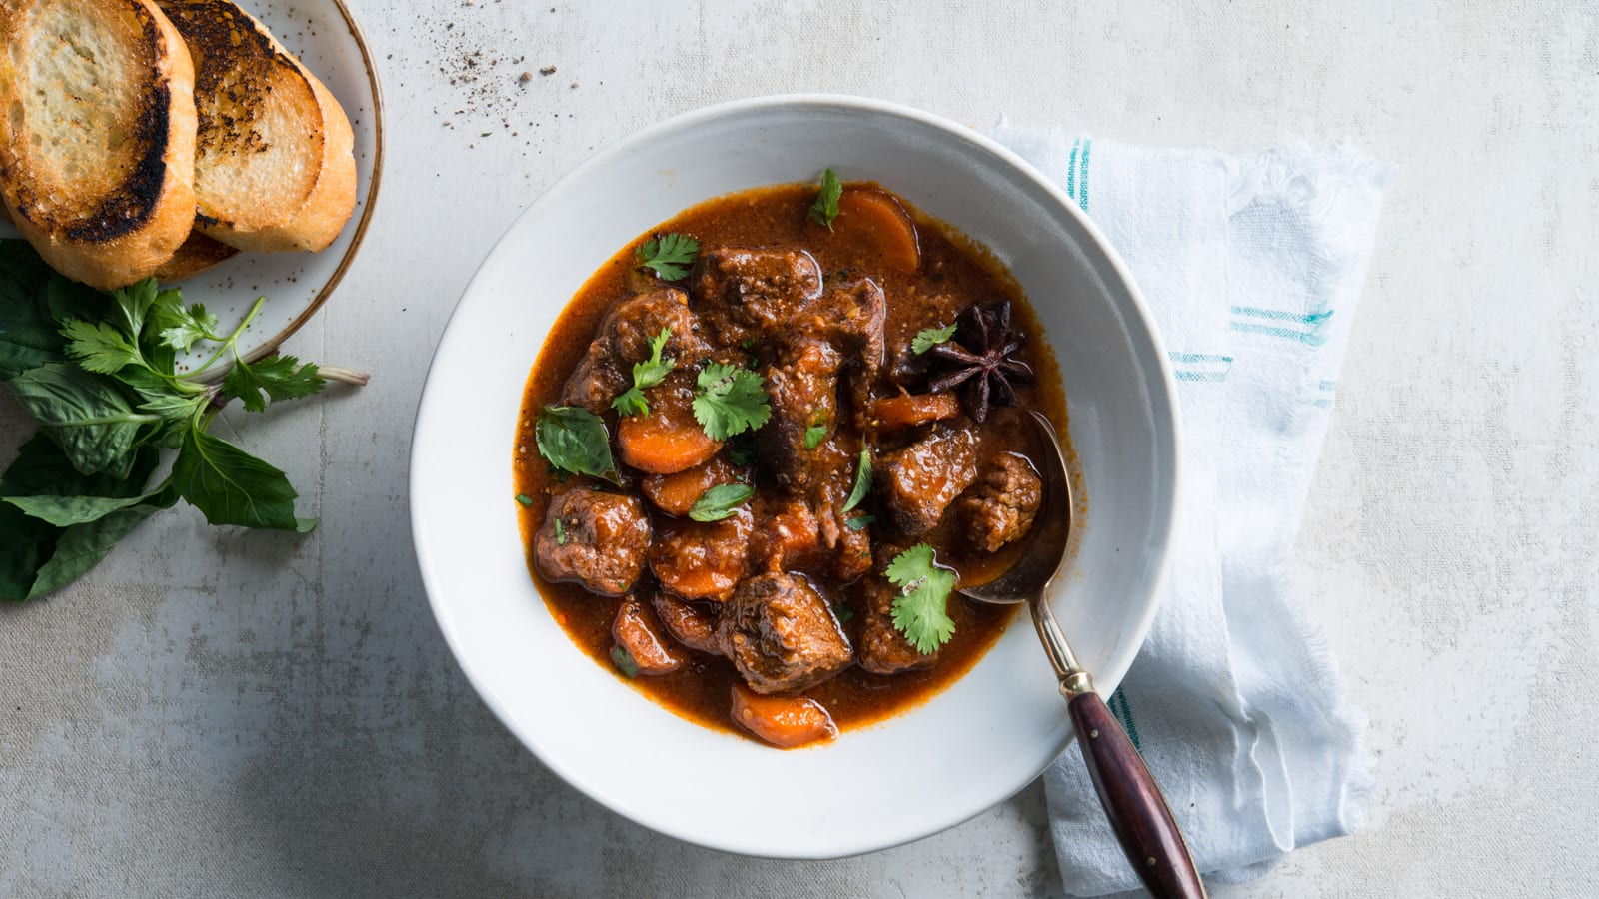

Serves 6

Ingredients:

* 2 pounds beef stew meat, cut into 1-inch pieces
* 1 onion, chopped
* 1-inch ginger, peeled and chopped
* 3 cloves garlic, minced
* 2 tbsp fish sauce
* 2 tbsp sugar
* 2 tbsp high heat oil
* 3 whole star anise
* 1 tsp ground cinnamon
* 1 stalk lemongrass, smashed
* ¼ cup tomato paste
* 3-5 cups of chicken or beef broth, as needed
* 2 bay leaves
* 2 tbsp soy sauce
* 4 carrots, sliced ½ inch thick
* Green onions or cilantro, chopped – for serving
* Toasted French baguette – for serving (optional)

Instructions:

Marinate beef, onions, ginger, garlic, fish sauce and sugar in a large sealable plastic in the refrigerator for 4 to 24 hours.

Heat oil over medium-high heat in a heavy, large pot or Dutch oven. Toast star anise and cinnamon until fragrant, about 30 seconds. Brown beef, onions, marinade and lemongrass in batches, 5 to 7 minutes. Stir in tomato paste to coat.

Cover with broth and add bay leaves and soy sauce. Bring to a boil, then reduce heat to a simmer. Cook for 1 to 1.5 hours, until beef is tender. Add carrots during the last 15 minutes of cooking time. Top with green onions or cilantro and serve alongside toasted baguette.